**Birla Institute of Technology & Science, Pilani**

**Work Integrated Learning Programmes Division**

**First Semester 2022-2023**

**Mid-Semester Test (EC-2 Regular)**

Course No. : SE ZG685

Course Title : Software Product Management

Nature of Exam : Open Book

Weightage : 30%

No. of Pages = 3

No. of Questions = 4

Duration : 2 Hours

Date of Exam : 24/09/2022 (FN)

Note to Students:

1. Please follow all the *Instructions to Candidates* given on the cover page of the answer book.
2. All parts of a question should be answered consecutively. Each answer should start from a fresh page.
3. Assumptions made if any, should be stated clearly at the beginning of your answer.
4. LOANS is a micro-finance institution helps marginal business owners by providing loans – and hope – to the poorest. Being product manager/owner,
   1. Identify software product opportunities [3]
   2. Identify risks in assessment [3]
   3. How to Build-Measure-Learn and Pivot for the opportunities and risks identified above? [3]

Ans:

A)

1. Financial education: Many of the individuals who seek microfinance services lack basic financial knowledge and skills. MFIs can help bridge this gap by providing financial education and training, such as budgeting, saving, and managing debt.
2. Non-financial support: Starting and running a business can be a daunting task, and many entrepreneurs may require non-financial support to succeed. This can include mentorship, business planning, and access to markets and other resources.
3. Insurance: Low-income individuals often face financial shocks such as illness, accidents, or crop failure that can cause significant financial setbacks. MFIs can offer insurance products that help individuals manage these risks and protect themselves from the consequences of unexpected events.
4. Digital financial services: Many underserved populations lack access to traditional banking services, but they may have access to mobile phones and other digital devices. MFIs can provide digital financial services such as mobile banking, digital payments, and other financial products that can be accessed through these devices.
5. Social empowerment: Poverty can be a deeply disempowering experience, and many marginalized individuals lack the confidence and self-esteem needed to pursue their goals. MFIs can provide social empowerment programs that help individuals build self-confidence, leadership skills, and other qualities that can help them succeed in their personal and professional lives.

b)

* Usability risk
* Feasibility risk (technical feasibility)
* Business viability risk

c)

**Build** -> Product -> **Measure** -> Data-> **Learn** -> Ideas -> **Build**

First will go with idea and risk, and then will go users (for feedback) , and then will build protoype and feedback and learn and get ideas. Till mvp for the market.

Measure of key metrics

Number of users,

Pivot -> Pivot- making changes to improve the metrics for better business (changing strategy)

Below risk and validate by BML cycle

* Usability risk
* Feasibility risk (technical feasibility)
* Business viability risk

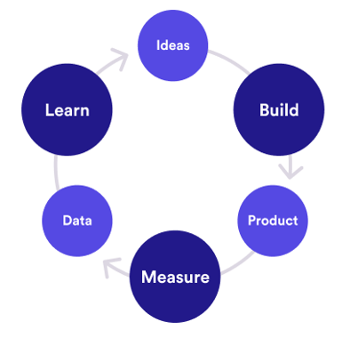

1. XYZ 24|7 is an online platform where you have access to a wide range of services such as online pharmacy, [online doctor consultations](https://www.apollo247.com/specialties), and diagnostic [lab tests at home](https://www.apollo247.com/lab-tests). We also provide expert solutions for chronic conditions and COVID-care with a secured digital vault, where you can safely upload all your medical reports.
   1. Identify software product opportunities [3]
   2. Identify risks in assessment [3]
   3. How to Build-Measure-Learn and Pivot for the opportunities and risks identified above? [3]

Ans:

* Order medicine
* Order for lab test and home sample can be collected
* Online consultation with doctor
* Provide symptom and get consult
* Will get loyalty points (health credit) based on app we used

**Chatgpt ans**

Apollo 24/7 is a healthcare app that provides a range of services to users, including doctor consultations, medicine delivery, lab tests, and more. The app's value proposition can be summarized as follows:

Convenience: With Apollo 24/7, users can access healthcare services from the comfort of their own homes. They can consult with doctors, order medicines, and schedule lab tests without having to visit a hospital or clinic.

Accessibility: The app is available 24/7, which means users can access healthcare services at any time, day or night. This can be particularly useful in emergencies or for those who have busy schedules.

Quality: The app provides access to experienced doctors and healthcare professionals who can provide high-quality medical advice and treatment. Users can also order genuine medicines and schedule lab tests from trusted partners.

Affordability: The app offers competitive pricing for its services, making healthcare more accessible and affordable for all.

Personalization: The app offers personalized healthcare recommendations based on user preferences and medical history. This helps users get the right care and treatment for their specific needs.

Overall, Apollo 24/7 offers a convenient, accessible, and affordable way for users to access high-quality healthcare services anytime, anywhere.

b)

* Value risk
* Usability risk
* Feasibility risk (technical feasibility)
* Business viability risk

c)

**Build** -> Product -> **Measure** -> Data-> **Learn** -> Ideas -> **Build**

First will go with idea and risk, and then will go users (for feedback) , and then will build protoype and feedback and learn and get ideas. Till mvp for the market.

Measure of key metrics

Number of users,

Pivot -> Pivot- making changes to improve the metrics for better business (changing strategy)

Below risk and validate by BML cycle

* Value risk
* Usability risk
* Feasibility risk (technical feasibility)
* Business viability risk

Example: **Bounce**

Minimum feature:

•Book

•Unlock

•End ride

•Pay

Features that can be left out for now:

•Give feedback (assuming there is a call center)

•View bike model and year of manufacturing

Frequent user analytics

**ChatGpt**

Build: The first step was to build a Minimum Viable Product (MVP) of the app, which included the core features such as doctor consultations, medicine delivery, and lab tests. The MVP was built based on the assumptions and hypotheses of the team about what users would want and need.

Measure: Once the MVP was built, the team started measuring how users were interacting with the app. They used various metrics such as user engagement, retention, and feedback to determine how well the app was meeting user needs and whether there were any areas for improvement.

Learn: Based on the metrics and feedback, the team learned that users were primarily using the app for doctor consultations and medicine delivery, and less for lab tests. They also found that users wanted more personalized recommendations and a wider range of healthcare services.

Pivot: With these learnings in mind, the team decided to pivot the app's focus towards personalized healthcare recommendations and a wider range of services. They added new features such as health assessments, health tips, and online therapy to the app to meet these needs.

Through the BML framework, the Apollo 24/7 app was able to quickly iterate and improve based on user feedback, leading to a more successful and user-friendly product.

Risks identified:

Feasibility risk (Technical Risks): There is a risk of technical issues such as app crashes, bugs, and security vulnerabilities that could impact the user experience and trust in the app. The likelihood of these risks can be assessed through regular testing and monitoring of the app's technical performance. The impact of these risks can be mitigated through prompt resolution and communication with users.

Business viability (Regulatory Risks): There are regulatory risks related to the healthcare industry, such as compliance with data privacy laws and medical regulations. The likelihood of these risks can be assessed through regular compliance audits and adherence to industry standards. The impact of these risks can be mitigated through proactive compliance measures and clear communication with users.

Value risk (Competition Risks): There is a risk of competition from other healthcare apps that offer similar services to Apollo 24/7. The likelihood of these risks can be assessed through regular monitoring of the competitive landscape and user feedback. The impact of these risks can be mitigated through continuous innovation, differentiation, and building strong brand loyalty.

Usability risk (User Adoption Risks): There is a risk that users may not adopt the app due to a lack of awareness, trust, or usability issues. The likelihood of these risks can be assessed through user surveys, feedback, and metrics such as user retention and engagement. The impact of these risks can be mitigated through effective marketing and communication strategies, user-friendly design, and building trust through high-quality healthcare services.

1. An over-the-top (OTT) media service is a [media](https://en.wikipedia.org/wiki/Media_(communications)) service offered [directly to viewers](https://en.wikipedia.org/wiki/Direct-to-consumer) via the [Internet](https://en.wikipedia.org/wiki/Internet). OTT bypasses [cable](https://en.wikipedia.org/wiki/Cable_television), [broadcast](https://en.wikipedia.org/wiki/Broadcast_television), and [satellite television](https://en.wikipedia.org/wiki/Satellite_television) platforms, the types of companies that traditionally act as controllers or distributors of such content. Being product manager/owner,
   1. Identify software product opportunities [3]
   2. Identify risks in assessment [3]
   3. How to Build-Measure-Learn and Pivot for the opportunities and risks identified above? [3]

Ans:

a)

ChatGpt

• **Flexibility**: Traditional television platforms often have fixed schedules, which may not be convenient for viewers with busy schedules. OTT media services offer greater flexibility, allowing viewers to watch their favorite shows and movies on-demand, at any time that is convenient for them.

• **Personalization**: Traditional television platforms often offer a limited selection of programming, with little choice for viewers to personalize their viewing experience. OTT media services offer personalized recommendations and curated playlists based on viewers' viewing history and preferences, allowing them to discover new content that is tailored to their interests.

• **Access**: Traditional television platforms may not be accessible to viewers in remote or underserved areas, who may have limited access to cable, broadcast, or satellite services. OTT media services can be accessed from any location with an internet connection, making them accessible to viewers regardless of their geographic location.

• **Affordability**: Traditional television platforms often come with high subscription fees and additional costs for premium content. OTT media services offer more affordable alternatives, with lower subscription fees and a wide range of free and paid content options.

• **Variety**: Traditional television platforms may offer limited programming options, with little diversity in terms of content and representation. OTT media services offer a wider range of programming options, with a greater variety of genres, languages, and cultural perspectives.

b)

* Value risk
* Usability risk
* Feasibility risk (technical feasibility)
* Business viability risk

c)

Refer to 1b

1. ABC is a General Insurance company, which offer Car, Two-Wheeler, Taxi and Health Insurance plans. Being product manager/owner,
   1. Describe Product-Market fit analysis [3]
   2. Provide the Story Map using Kano Model [3]
   3. Explain the Rapid Prototyping process to reach MVP [3]

Ans

a)

Product-Market fit analysis is a process of determining whether a product is meeting the needs of its target market. It involves evaluating how well the product is solving the problems and addressing the needs of the customers. To perform a Product-Market fit analysis, the following steps can be taken:

1. Define the target market and the customers' needs and pain points

2. Evaluate how well the product addresses these needs

3. Determine if there is a demand for the product

4. Analyze the competition and identify the unique selling proposition of the product

5. Identify the key metrics to measure the success of the product in the market



b)

This is just an example for kano model

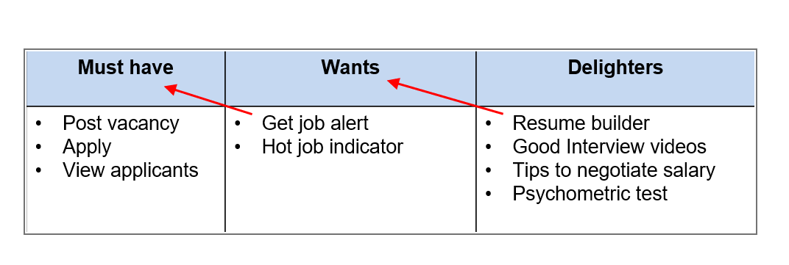

**ChatGpt**

• **Must-Haves**: These are basic features that customers expect as a minimum requirement from ABC's insurance products. For example, customers purchasing car insurance expect coverage for accidents, theft, and third-party liability. For health insurance, customers expect coverage for hospitalization and medical expenses. These features are essential for customers to consider purchasing ABC's insurance products.

• **Performance Features**: These are features that customers are satisfied with when they are present and dissatisfied when they are absent. For example, customers purchasing car insurance may appreciate additional benefits such as roadside assistance or a zero-depreciation policy. Similarly, customers purchasing health insurance may value features such as cashless hospitalization, wellness programs, and preventive care. These features help to differentiate ABC's products from competitors and increase customer satisfaction.

• **Delighters**: These are features that customers may not expect but are pleasantly surprised by when present. For example, ABC may offer unique features such as accident forgiveness or concierge services for car insurance customers, or access to telemedicine and virtual consultations for health insurance customers. These features can create a strong emotional connection with customers and increase loyalty to ABC's brand

c)

Map the problem ->        Sketch the solution -> Choose the best solution -> Storyboard -> Prototype -> Test

1. ABC is a General Insurance company, which offer Car, Two-Wheeler, Taxi and Health Insurance plans. Being product manager/owner,
   1. Describe Product-Market fit analysis [3]
   2. Provide the Story Map using Kano Model [3]
   3. Explain the Rapid Prototyping process to reach MVP [3]

Ans:

1. ABC is a General Insurance company, which offer Car, Two-Wheeler, Taxi and Health Insurance plans. Being product manager/owner,
   1. Describe Product-Market fit analysis [3]
   2. Provide the Story Map using Kano Model [3]
   3. Explain the Rapid Prototyping process to reach MVP [3]
2. When we are hearing the term E-Books and Digital Library everywhere, and the phone is a smartphone now, it has also changed the face of education in India. There are so many students who belong to tier-2 cities, do not have the proper resources and lack of e-books and libraries. Being product manager/owner,
   1. Identify users in the online library and e-books application [3]
   2. Provide the Critical success factors in the product [3]
   3. Fill the lean canvas board [3]

Ans:

A)

chatGpt:

The potential users of the online library and e-books application could include students, researchers, educators, and book enthusiasts who are looking for a more convenient and accessible way to access books and educational materials

b)

Product can be tied with govt (or ngo) to get app in lowest price and also can provide subsidiary to tier 2 city students

ChatGpt

Provide the Critical success factors in the product: Some critical success factors for the online library and e-books application could include:

1. A user-friendly interface that allows users to easily search, browse and access the books and materials they need.

2. A vast collection of books and educational materials that covers various subjects and topics.

3. Reliable and fast access to the books and materials, with minimal downtime or interruptions.

4. Competitive pricing that is affordable for students and other users.

5. A strong marketing strategy that can attract and retain a large user base.

c)

| **Key Metrics** | **Value Proposition** | **Problem** | **Solution** |
| --- | --- | --- | --- |
| Customer | Online library and | Lack of access to | Comprehensive and |
| Segments | e-books | educational | constantly growing |
|  |  | resources | library of e-books |
| Channels | Digital marketing | Limited access to | User-friendly and |
|  | and advertising | educational | intuitive |
|  |  | resources | interface |
| Revenue | Subscription-based | Limited access to | Flexible and |
| Streams | model | educational | affordable pricing |
|  |  | resources | model |
| Cost | Digital resources | Difficulty | Strong partnerships |
| Structure | acquisition and | finding relevant | and collaborations |
|  | curation | and high-quality | with educational |
|  |  | educational | institutions, |
|  |  | resources | publishers, and |
|  |  |  | authors |
| Key Partners | Publishers, | Inefficient | Reliable and |
|  | educational | and insecure | secure |
|  | institutions | infrastructure | infrastructure |
|  |  |  |  |
| Key Activities | E-book acquisition, |  |  |
|  | curation and |  |  |
|  | digitization |  |  |
|  |  |  |  |
| Unique Value | High-quality |  |  |
| Proposition | digital resources |  |  |
|  | and easy access to |  |  |
|  | educational |  |  |
|  | materials |  |  |

1. When we are hearing the term E-Books and Digital Library everywhere, and the phone is a smartphone now, it has also changed the face of education in India. There are so many students who belong to tier-2 cities, do not have the proper resources and lack of e-books and libraries. Being product manager/owner,
   1. Identify users in the online library and e-books application [3]
   2. Provide the Critical success factors in the product [3]
   3. Fill the lean canvas board [3]
2. When we are hearing the term E-Books and Digital Library everywhere, and the phone is a smartphone now, it has also changed the face of education in India. There are so many students who belong to tier-2 cities, do not have the proper resources and lack of e-books and libraries. Being product manager/owner,
   1. Identify users in the online library and e-books application [3]
   2. Provide the Critical success factors in the product [3]
   3. Fill the lean canvas board [3]
3. Describe the senior citizen friendly user experience model of both desktop web client and mobile application for the ecommerce booking application. [3]

Ans:

* **Learnability**: How easy is it for users to accomplish basic tasks the first time they encounter the design?
* **Efficiency**: Once users have learned the design, how quickly can they perform tasks?
* **Memorability**: When users return to the design after a period of not using it, how easily can they re-establish proficiency?
* **Errors**: How many [errors](https://www.nngroup.com/articles/slips/) do users make, how severe are these errors, and how easily can they recover from the errors?
* **Satisfaction**: How pleasant is it to use the design?

Example

Consider the following:

* Learnability: How quickly can you learn to use these - washing machine, Gmail, online banking
* Efficiency: How efficiently can you accomplish your task using these – MS Word, 50 process templates to choose from in Kissflow
* Memorability: How long does it take to use these when you return again to use them - Airport kiosk to print boarding pass, Movie theatre kiosk to print ticket
* Errors: How many errors do you make while buying a product on Flipkart?
* Satisfaction: How pleasant was your experience using MakeMyTrip.com?

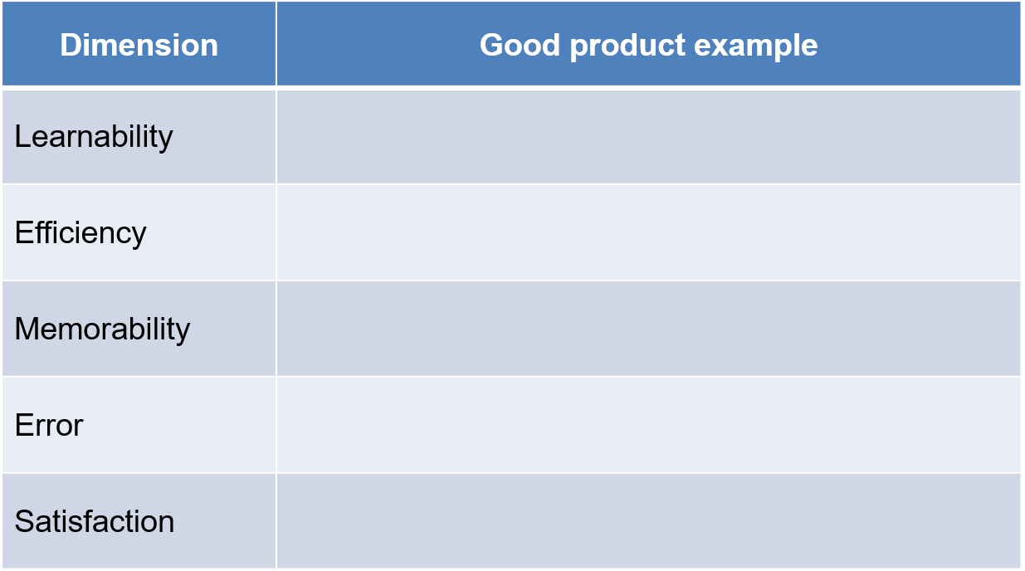

1. Describe the kid friendly user experience model of both desktop web client and mobile application for the online education application. [3]
2. Describe the customer friendly user experience model of both desktop web client and mobile application for the online healthcare services booking application. [3]

*****